SIMATS ENGINEERING
ASSESSMENT TOOL 2

COURSE NAME: Cryptography and Network Security
COURSE CODE: CSA5116

COURSE OUTCOME COVERED
CO1: Apply classical encryption techniques using symmetric and asymmetric ciphers to encrypt and decrypt data for the ensuring data security. (BL3, BL4)
Assessment Tool Weightage: 20%
QUESTIONS: 5 Total Marks:50

Annexure A
CONCEPT MAPPING

Code of Conduct:
I Anusha R(192321134) (Name / Reg No) certify that this submission is my original work and that I have adhered to the guidelines specified for this assessment.
I understand that any violation of academic integrity rules will result in disciplinary action.
Signature of the student: Anusha R

Annexure A
CONCEPT MAPPING
1. Create a concept map linking the following: Security Attacks, Threats, Risks and
Security Goals (Confidentiality, Integrity, Availability. Perform the following tasks:
a. Show how each attack leads to specific threats and risks
b. Map how security goals help mitigate them Provide one real-world
example for each link
2. Develop a concept map comparing substitution techniques: Caesar Cipher,
Monoalphabetic Cipher, Vigenère Cipher and Hill Cipher. Perform the following tasks
to connect based on: Key usage, Complexity and Security strength. Analyze which
technique is most secure and why.
3. Construct a concept map for Classical Encryption Schemes: Substitution
Techniques and Transposition Techniques. Perform the following tasks:
a. Show differences and similarities
i.Map how each affects the Data structure and Security level
ii.Analyze which is more vulnerable to attacks and why
4. Create a concept map connecting Steganography concepts: Data Hiding,
Watermarking and Survivability. Perform the following tasks:
a. Show relationships between these concepts
b. Analyze how each contributes to secure communication
c. Include one real-world application for each
5. Draw a concept map linking number theory concepts used in cryptography:
Modular Inverse, Extended Euclid Algorithm, Fermat’s Little Theorem, Euler’s Phi
Function and Euler’s Theorem. Perform the following tasks:
a. Show how each concept is mathematically connected
b. Map their role in encryption/decryption
c. Analyze which concept is most critical for public key cryptography and
justify
1. Concept Map: Security Attacks, Threats, Risks and Security Goals (CIA Triad)
Concept Map


- How attacks lead to threats and risks
Attack | Threat | Risk
Interception | Unauthorized access | Confidential information leaked
Modification | Data tampering | Incorrect business decisions
DoS Attack | Service disruption | Financial loss and downtime

- Security goals and real-world examples
Security Goal | Mitigation | Real-world Example
Confidentiality | Encryption | HTTPS protects online banking data
Integrity | SHA-256 Hash & Digital Signature | Software update verification
Availability | Backup servers & Firewalls | Cloud services with redundant servers

2. Concept Map: Comparison of Substitution Techniques
Concept Map

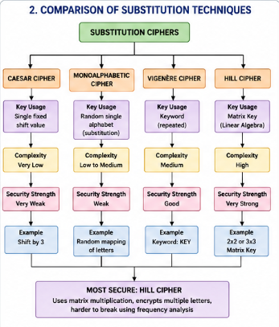

Comparison Table

Cipher | Key Usage | Complexity | Security Strength
Caesar | Fixed Shift | Very Low | Very Weak
Monoalphabetic | One Random Alphabet | Medium | Weak
Vigenère | Repeating Keyword | Medium | Good
Hill Cipher | Matrix Key | High | Very Strong

Analysis
Hill Cipher is the most secure classical substitution technique because:
- Uses matrix multiplication.
- Encrypts multiple letters simultaneously.
- Harder to break using frequency analysis.
- Produces complex ciphertext patterns.

3. Concept Map: Classical Encryption Schemes
Concept Map
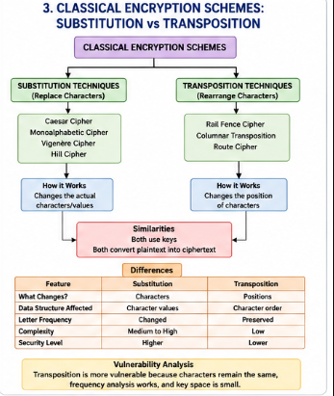

a(i). Differences and Similarities
Feature | Substitution | Transposition
Changes | Characters | Positions
Data Structure | Character values | Character order
Security | Medium | Low
Letter Frequency | Modified | Preserved

a(ii). Vulnerability Analysis
Transposition techniques are more vulnerable because:
- Characters remain unchanged.
- Frequency analysis still works.
- Small key space.
- Easily broken using brute-force attacks.
Substitution ciphers offer comparatively better protection because character identities change

4. Concept Map: Steganography
Concept Map
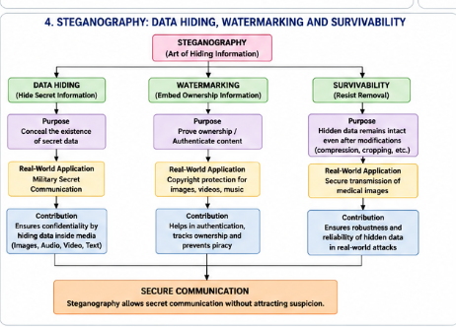
a. Relationships
- Data Hiding conceals secret information.
- Watermarking proves ownership.
- Survivability ensures hidden data remains intact after modifications.
b. Contribution to Secure Communication
Concept | Contribution
Data Hiding | Conceals confidential information
Watermarking | Protects ownership and copyright
Survivability | Maintains hidden data despite compression or editing

c. Real-world Applications
Concept | Application
Data Hiding | Military secret communication
Watermarking | Copyright protection for digital images and videos
Survivability | Secure transmission of medical images

5. Concept Map: Number Theory in Cryptography
Concept Map
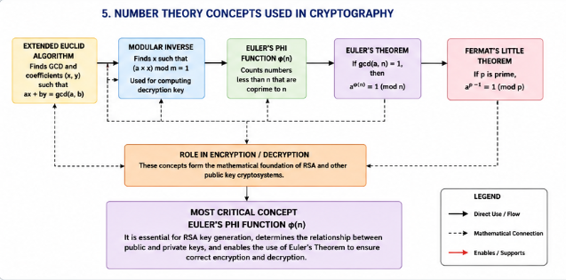

a. Mathematical Connections
- Extended Euclidean Algorithm computes the Modular Inverse.
- Euler's Phi Function calculates the number of integers relatively prime to n.
- Euler's Theorem uses Euler's Phi Function.
- Fermat's Little Theorem is a special case of Euler's Theorem for prime numbers.
- These concepts collectively enable modular arithmetic used in public-key cryptography.
b. Role in Encryption/Decryption
Concept | Role
Extended Euclid Algorithm | Finds modular inverse for private key generation
Modular Inverse | Computes decryption key
Euler's Phi Function | Generates RSA keys
Euler's Theorem | Forms the mathematical basis of RSA
Fermat's Little Theorem | Simplifies modular exponentiation for prime moduli

C. Most Critical Concept
Euler's Phi Function (φ(n)) is the most critical concept for public-key cryptography.
Justification
- It is essential for RSA key generation.
- Determines the relationship between the public and private keys.
- Enables computation of the modular inverse used to derive the private key.
- Ensures the correctness of encryption and decryption operations based on Euler's Theorem.
- Without φ(n), RSA key generation and secure decryption would not be possible.

